Convex and concave polyhedral

Definition
# Source: AI Source: Provided by: [Data Path: Persons Table -> ID Column: 1, Name_En Column: Motasem Essam] -> From: [ChatGPT] on [7/25/2026]
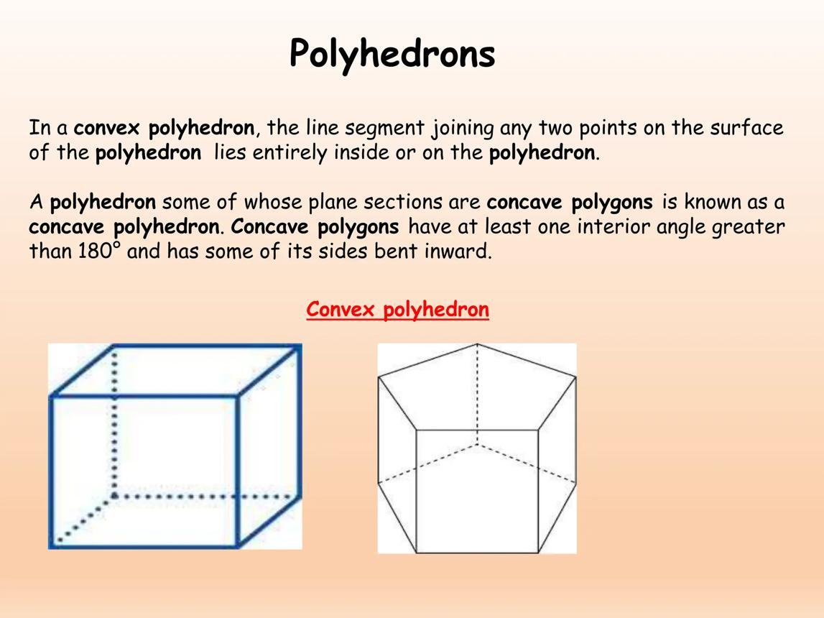
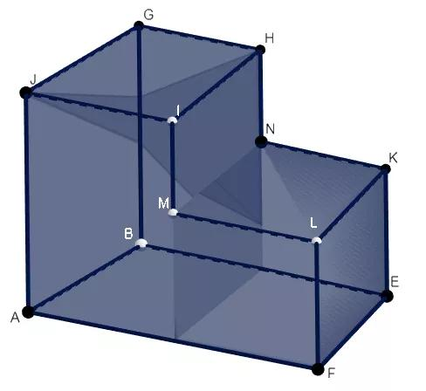
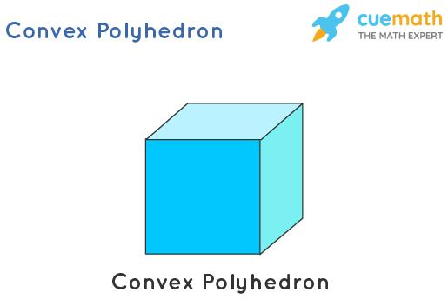
A polyhedron is a three-dimensional geometric solid whose boundary consists of flat polygonal faces joined along straight edges.
Polyhedra can be classified according to their shape into two major categories:
- Convex polyhedron: A polyhedron with no inward indentations. Every line segment joining two points in the solid lies entirely inside or on its boundary.
- Concave polyhedron: A nonconvex polyhedron with at least one inward indentation. There are two points in the solid for which the line segment joining them passes outside the solid.
This classification describes the overall geometry of a solid, rather than the number or shape of its faces.

Simple Definitions
# Source: AI Source: Provided by: [Data Path: Persons Table -> ID Column: 1, Name_En Column: Motasem Essam] -> From: [ChatGPT] on [7/25/2026]
Convex polyhedron: A solid with no inward dents, where every straight segment joining two points in the solid stays inside it.
Concave polyhedron: A solid with an inward dent, where at least one straight segment joining two points in the solid passes outside it.

Classification Tree
# Source: AI Source: Provided by: [Data Path: Persons Table -> ID Column: 1, Name_En Column: Motasem Essam] -> From: [ChatGPT] on [7/25/2026]
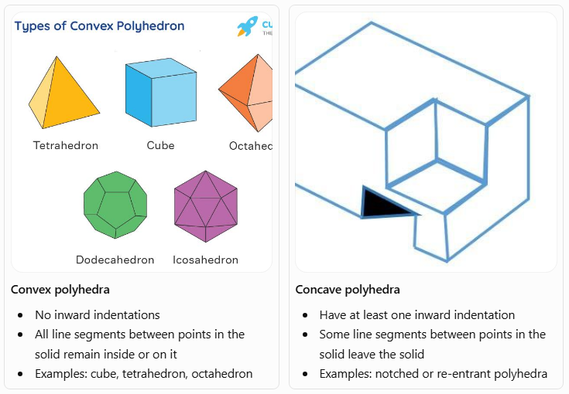
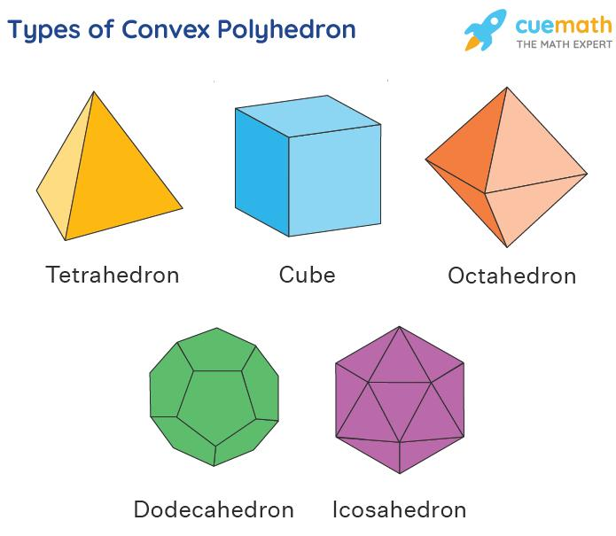
Convex polyhedra
- No inward indentations
- All line segments between points in the solid remain inside or on it
- Examples: cube, tetrahedron, octahedron
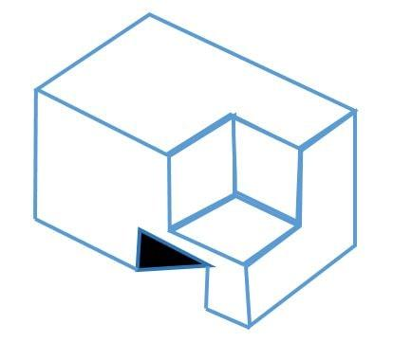
Concave polyhedra
- Have at least one inward indentation
- Some line segments between points in the solid leave the solid
- Examples: notched or re-entrant polyhedra

Convex Polyhedra
# Source: AI Source: Provided by: [Data Path: Persons Table -> ID Column: 1, Name_En Column: Motasem Essam] -> From: [ChatGPT] on [7/25/2026]
A convex polyhedron is a polyhedron whose solid region is convex. For any two points $A$ and $B$ in the solid, the entire segment $\overline{AB}$ lies inside or on the boundary.
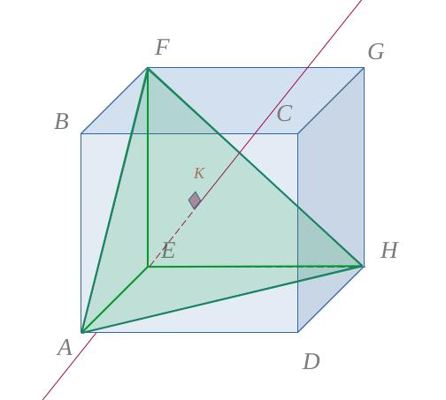

1. Characteristics of Convex Polyhedra
# Source: AI Source: Provided by: [Data Path: Persons Table -> ID Column: 1, Name_En Column: Motasem Essam] -> From: [ChatGPT] on [7/25/2026]
- They have no inward dents or re-entrant corners.
- Every face lies in a supporting plane, with the entire solid on one side of that plane.
- A segment joining any two points in the solid does not leave it.
- Their surface encloses a bounded three-dimensional region.
- Euler's formula applies to a convex polyhedron:
$$V-E+F=2$$
where $V$ is the number of vertices, $E$ is the number of edges, and $F$ is the number of faces.

2. Examples of Convex Polyhedra

Cube
# Source: AI Source: Provided by: [Data Path: Persons Table -> ID Column: 1, Name_En Column: Motasem Essam] -> From: [ChatGPT] on [7/25/2026]
Six square faces, eight vertices, and twelve edges.
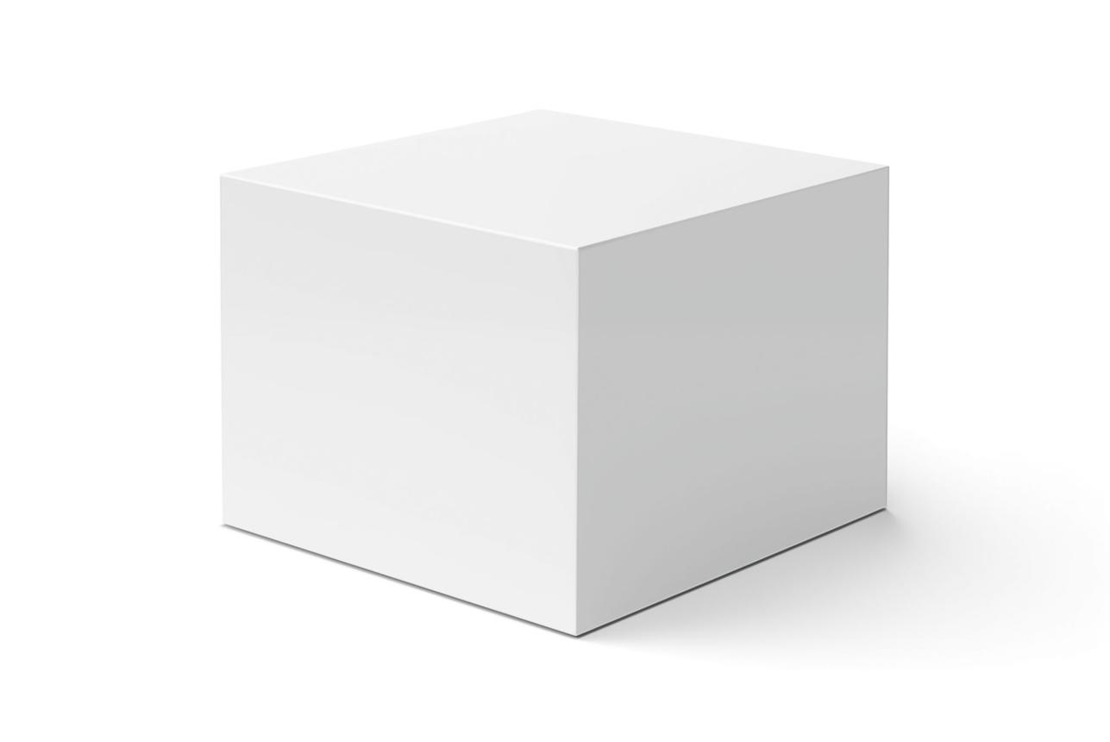

Tetrahedron
# Source: AI Source: Provided by: [Data Path: Persons Table -> ID Column: 1, Name_En Column: Motasem Essam] -> From: [ChatGPT] on [7/25/2026]
Four triangular faces, four vertices, and six edges.
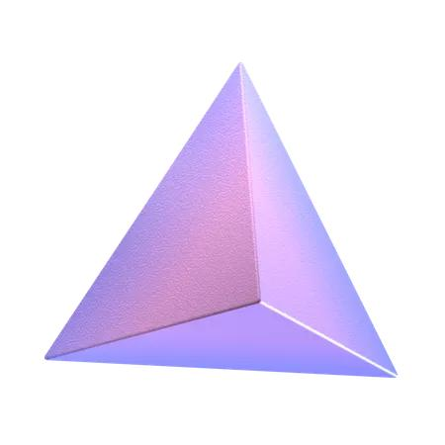

Triangular prism
# Source: AI Source: Provided by: [Data Path: Persons Table -> ID Column: 1, Name_En Column: Motasem Essam] -> From: [ChatGPT] on [7/25/2026]
Two triangular bases and three rectangular lateral faces in a right triangular prism.
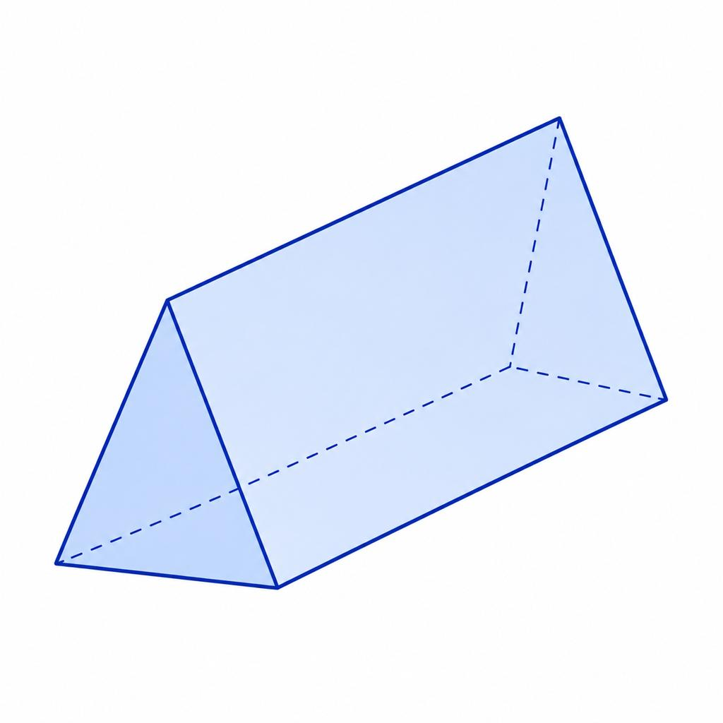

Dodecahedron
# Source: AI Source: Provided by: [Data Path: Persons Table -> ID Column: 1, Name_En Column: Motasem Essam] -> From: [ChatGPT] on [7/25/2026]
Twelve regular pentagonal faces in the regular form.
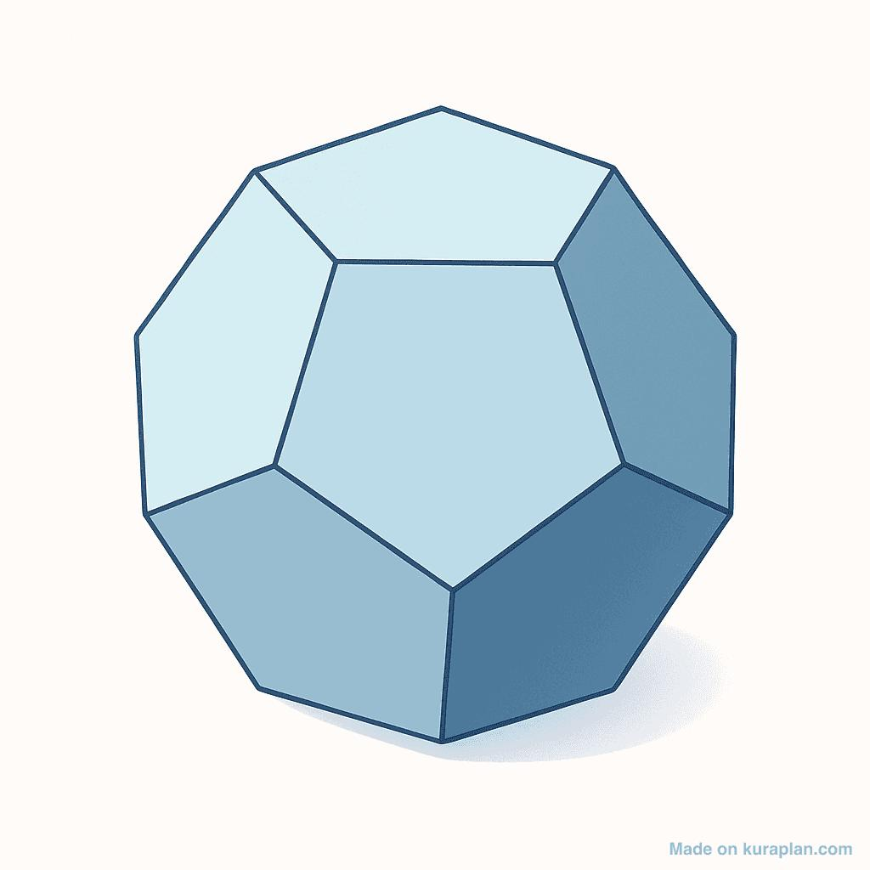

Concave Polyhedra
# Source: AI Source: Provided by: [Data Path: Persons Table -> ID Column: 1, Name_En Column: Motasem Essam] -> From: [ChatGPT] on [7/25/2026]
A concave polyhedron is a nonconvex polyhedron whose solid region contains at least one inward indentation. Some line segments joining points inside the solid pass partly outside it.

1. Characteristics of Concave Polyhedra
# Source: AI Source: Provided by: [Data Path: Persons Table -> ID Column: 1, Name_En Column: Motasem Essam] -> From: [ChatGPT] on [7/25/2026]
- They have at least one inward indentation or re-entrant part.
- At least one segment joining two points of the solid passes outside the solid.
- Some interior dihedral angles, under the usual convention, are greater than ${180}^{∘}$.
- Their faces are still flat polygons, and their edges are still straight segments.
- Their surface area is the sum of their face areas, assuming the faces form the boundary without overlap.
- Their volume can be found by decomposing the solid into simpler solids or subtracting missing portions from a larger solid.
A concave polyhedron is still a polyhedron. Concavity does not mean that its faces or edges must be curved.

2. Examples of Concave Polyhedra

Notched polyhedron
# Source: AI Source: Provided by: [Data Path: Persons Table -> ID Column: 1, Name_En Column: Motasem Essam] -> From: [ChatGPT] on [7/25/2026]
A block-like solid with a rectangular notch removed from one side. The indentation makes the solid concave.
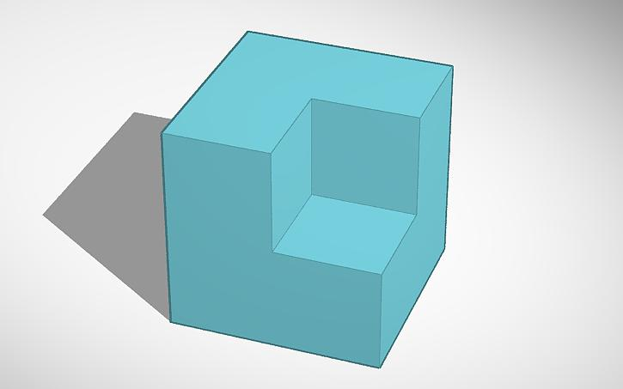

L-shaped polyhedron
# Source: AI Source: Provided by: [Data Path: Persons Table -> ID Column: 1, Name_En Column: Motasem Essam] -> From: [ChatGPT] on [7/25/2026]
An L-shaped polygon extruded to a constant depth forms a concave polyhedron. The inside corner creates a re-entrant region.
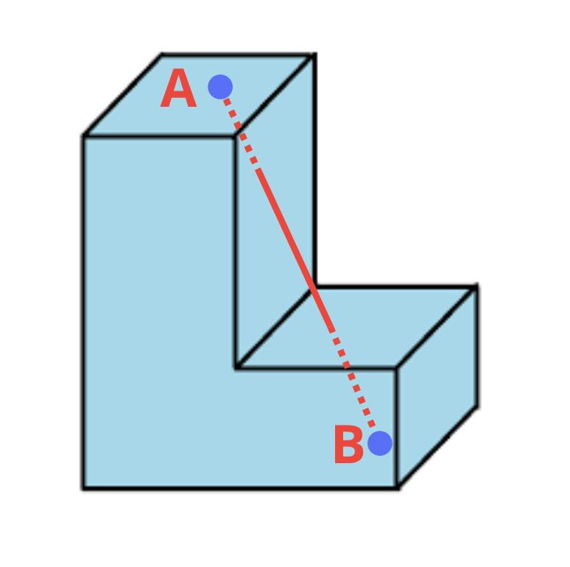

Cross-shaped polyhedron
# Source: AI Source: Provided by: [Data Path: Persons Table -> ID Column: 1, Name_En Column: Motasem Essam] -> From: [ChatGPT] on [7/25/2026]
A suitable three-dimensional cross-shaped solid can be concave when its outline contains inward corners.
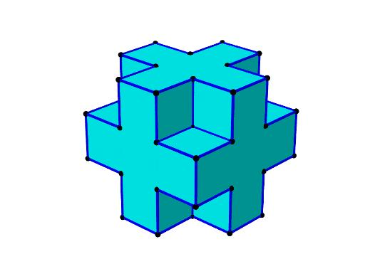

Convex vs. Concave Polyhedra
# Source: AI Source: Provided by: [Data Path: Persons Table -> ID Column: 1, Name_En Column: Motasem Essam] -> From: [ChatGPT] on [7/25/2026]
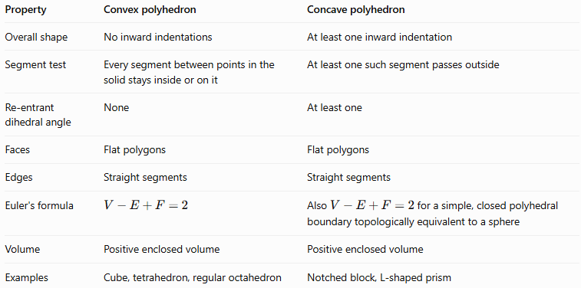
Property | Convex polyhedron | Concave polyhedron
Overall shape | No inward indentations | At least one inward indentation
Segment test | Every segment between points in the solid stays inside or on it | At least one such segment passes outside
Re-entrant dihedral angle | None | At least one
Faces | Flat polygons | Flat polygons
Edges | Straight segments | Straight segments
Euler's formula | $$V-E+F=2$$ | Also $V-E+F=2$ for a simple, closed polyhedral boundary topologically equivalent to a sphere
Volume | Positive enclosed volume | Positive enclosed volume
Examples | Cube, tetrahedron, regular octahedron | Notched block, L-shaped prism
Important: Concave polyhedra do not automatically violate Euler's formula. A typical concave solid with one closed, connected boundary and no tunnels still satisfies \(V-E+F=2\).

How to Determine Whether a Polyhedron Is Convex or Concave
# Source: AI Source: Provided by: [Data Path: Persons Table -> ID Column: 1, Name_En Column: Motasem Essam] -> From: [ChatGPT] on [7/25/2026]
Use the following tests.
Test 1: Look for an inward indentation
If the solid has a genuine inward dent, it is concave. If it has no such indentation, continue to the segment test.
Test 2: Apply the line-segment test
Choose any two points in the solid and imagine connecting them with a straight segment. If even one segment passes outside the solid, the solid is concave. If every segment stays inside or on the boundary, it is convex.
Test 3: Examine the interior dihedral angles
A convex polyhedron has interior dihedral angles less than ${180}^{∘}$. A concave polyhedron has at least one re-entrant interior dihedral angle greater than ${180}^{∘}$.

Mathematical Properties

1. Euler's formula
# Source: AI Source: Provided by: [Data Path: Persons Table -> ID Column: 1, Name_En Column: Motasem Essam] -> From: [ChatGPT] on [7/25/2026]
For a convex polyhedron, and for a simple closed polyhedral boundary topologically equivalent to a sphere:
$$\boxed{V-E+F=2}$$
For example, a cube has $V=8$, $E=12$, and $F=6$:
$$8-12+6=2$$
A concave polyhedron with the same topological type also satisfies this relation, regardless of its indentation.

2. Sum of face angles
# Source: AI Source: Provided by: [Data Path: Persons Table -> ID Column: 1, Name_En Column: Motasem Essam] -> From: [ChatGPT] on [7/25/2026]
For a convex polyhedron with $V$ vertices, the sum of all interior polygon angles across all faces is:
$$\boxed{{180}^{∘}\left(2E-2F\right)}$$
This follows by summing the interior angles of every polygonal face. A polygon with $k$ sides has an interior-angle sum of $\left(k-2\right){180}^{∘}$, and the total number of face-edge incidences is $2E$.
The same face-angle sum formula applies to a closed polyhedral surface with polygonal faces, including ordinary concave polyhedra.

3. Volume of a concave polyhedron
# Source: AI Source: Provided by: [Data Path: Persons Table -> ID Column: 1, Name_En Column: Motasem Essam] -> From: [ChatGPT] on [7/25/2026]
A concave polyhedron can often be divided into non-overlapping convex pieces:
$$\boxed{V_{\text{total}}=\sum_{i=1}^{m}{V_{i}}}$$
Alternatively, if a concave solid is formed by removing a portion from a larger solid:
$$\boxed{V_{\text{remaining}}=V_{\text{original}}-V_{\text{removed}}}$$
The same addition or subtraction principle can be used for surface-area calculations only after accounting for which surfaces are exposed and which are internal.

Worked Examples
# Source: AI Source: Provided by: [Data Path: Persons Table -> ID Column: 1, Name_En Column: Motasem Essam] -> From: [ChatGPT] on [7/25/2026]
Example 1: Classifying a cube
Problem: Is a cube convex or concave?
Solution:
A cube has no inward indentations. Every straight segment joining two points in the cube stays inside or on its boundary.
Therefore, a cube is a convex polyhedron.
It also satisfies Euler's formula:
$$V-E+F=8-12+6=2$$
Example 2: Classifying an L-shaped prism
Problem: An L-shaped polygon is extended uniformly to form a three-dimensional prism. Is the resulting solid convex or concave?
Solution:
The inside corner of the L-shaped cross-section creates an inward indentation. Two points can be chosen in different arms of the solid so that the segment between them passes outside the solid.
Therefore, the solid is a concave polyhedron.
Example 3: Finding the volume of a concave solid
Problem: A solid is made by removing a rectangular block measuring $2\text{ cm}×2\text{ cm}×3\text{ cm}$ from a larger rectangular block measuring $6\text{ cm}×4\text{ cm}×3\text{ cm}$. Find the remaining volume.
Step 1: Find the original volume.
$$V_{1}=6×4×3=72{\text{ cm}}^{3}$$
Step 2: Find the removed volume.
$$V_{2}=2×2×3=12{\text{ cm}}^{3}$$
Step 3: Subtract the removed volume.
$$V=72-12$$
$$\boxed{V=60{\text{ cm}}^{3}}$$
Answer: The remaining solid has a volume of $60{\text{ cm}}^{3}$. If the removed block creates an inward notch, the resulting solid is concave.

Applications
# Source: AI Source: Provided by: [Data Path: Persons Table -> ID Column: 1, Name_En Column: Motasem Essam] -> From: [ChatGPT] on [7/25/2026]

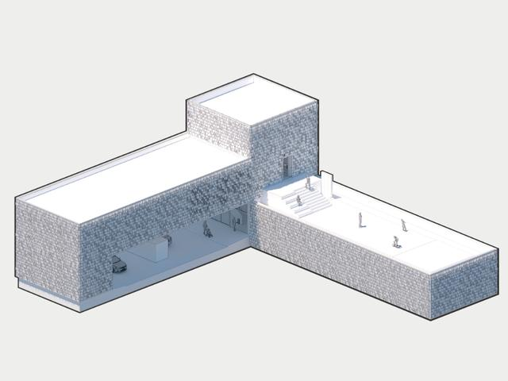
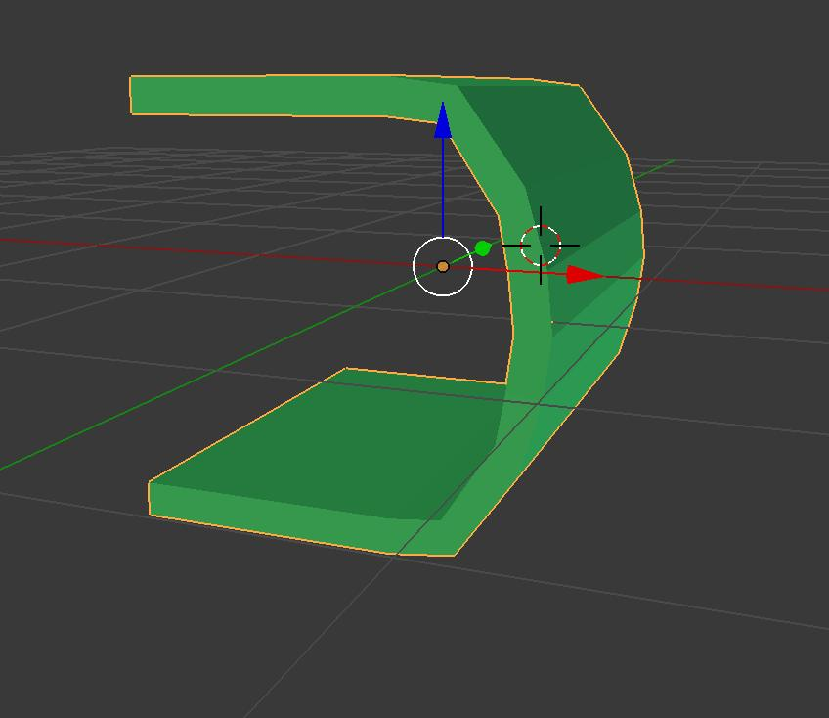
Convex and concave polyhedra are useful in several fields:
- Architecture: Classifying building forms and modeling structures with recesses and projections.
- Engineering: Calculating the volume and surface area of complex components.
- Computer graphics: Representing three-dimensional objects using polygonal meshes.
- 3D printing: Preparing solid models and checking their geometric boundaries.
- Mathematics: Studying convexity, spatial relationships, polygonal faces, and polyhedral topology.

Key Points
# Source: AI Source: Provided by: [Data Path: Persons Table -> ID Column: 1, Name_En Column: Motasem Essam] -> From: [ChatGPT] on [7/25/2026]
- A polyhedron is a solid bounded by polygonal faces.
- A convex polyhedron has no inward indentations and passes the line-segment test.
- A concave polyhedron has at least one inward indentation and fails the line-segment test.
- Both types have flat polygonal faces and straight edges.
- Convex and concave polyhedra can both satisfy Euler's formula when their closed boundaries are topologically equivalent to a sphere.
- Volume calculations for concave solids often involve adding simpler pieces or subtracting removed portions.

Conclusion
# Source: AI Source: Provided by: [Data Path: Persons Table -> ID Column: 1, Name_En Column: Motasem Essam] -> From: [ChatGPT] on [7/25/2026]
Convexity and concavity are fundamental ways of classifying polyhedra by their overall shape. Convex polyhedra have a uniformly outward form, while concave polyhedra contain at least one inward indentation. Recognizing this distinction helps with geometric classification, surface analysis, volume calculations, and three-dimensional modeling.

